Barak Barclay

ECE2411-001

HW #3

Feb 9, 2016

Feb 16, 2016

module Exmpl_3(A, B, C, D, F, G); // Line 1: A "-" cannot be used in module declaration. A ";" is neeeded //after ")". See side note.

input A, B, C; output D, F, G; // Line 2: Omit "s", put a ";" after "C" and "F", and lowercase "O". See side //note.

//output B // Line 3: Omit line b/c "B" is already an input. ";" would be needed after "B" if this line was //used.

and g1(D, A, B); // Line 4: The output should be listed first.

not (G, A); // Line 5: A ";" is neeeded after ")" instead of a ",". Not gate should have only 2 ports.

or (F, B, C); // Line 6: "OR" should be lowercase. "B" should have a "," instead of a ";" after it.

endmodule // Line 7: Omit ";".

//Side note: If only above commented corrections are done, "D" would be the output for two different //gates. Although it will complle, the simulation doesn't seem to like it and gives "D" a red line instead of //a green one. This can be fixed many ways. I choose to add another output "G" to use for the not gate //instead of "D".

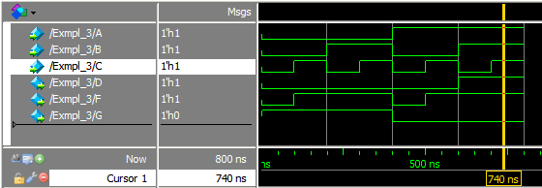

2.)(a)

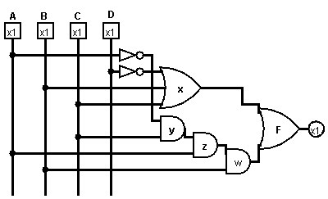

(b)

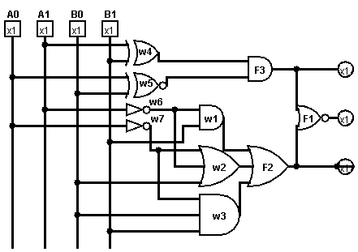

(c)

